Comparative Development Analysis of Turkey and 10 Different Countries
Report

Hakkı Erdem Çelik

Abstract
The aim of this project is to analyse the indicators that define the concept of ‘enlightened society’ in order to determine how close countries are to this concept and to see how far they have progressed or regressed over the years.At the same time, a few different countries have been subjected to this analysis in order to understand the difference between Turkey and other countries on the way to becoming an enlightened society. One of the main motivations is to determine the accuracy of the public opinion that ‘if we go back 50 years, we will go forward’ and to measure its reality.

Since the accuracy of the results obtained cannot be known with certainty, they are open to interpretation. However, when we compare the results by looking at the development levels of the countries, it is obvious that there are realistic results.

Keywords
Enlightened Society,Education Quality,Scientific Contribution,Interest in Art and Culture,Freedom,Moral Level,Rank,Time Series,Development,Interpolation,Linear Regression,Normalisation,Weighting

I. INTRODUCTION
The criteria of the enlightened society of this project, which aims to measure the reality of the frequently heard belief that ‘If we go back 50 years, we will go forward’ and at the same time aims to make inferences about countries with the criteria determined personally to the philosophical question ‘What is an enlightened society?’, are examined under the following headings.
Quality of Education, Scientific Contribution, Interest in Art and Culture, Freedom, Level of Morality, Normalization
The data appropriate to these selected criteria have been collected and organised and an overall score has been derived for each criterion for each year and for each selected country.
The selected year range is targeted as 2005 - 2025 and the selected countries are as follows:

The scores of the criteria for these countries for the specified years were derived and finally an enlightened society score was tried to be obtained from all these criteria.

Method

Working Principles and Intended Use of Linear Interpolation and Linear Regression

The methods used in missing data problems are as follows:
Linear Interpolation, Linear Regression
Linear Interpolation aims to predict the missing data by drawing a linear graph of the general data set. This method was preferred in terms of preserving reality. Linear Regression aims to predict the data after the data set along a general line. In cases where the desired years are missing, if the data set is complete until a certain time, future years are used in the prediction process.
B. Data Preprocessing and Coding Process
After the criteria were determined, data sets were searched on a global scale and data sets close to the desired format were found at some points.
While those with a general score remained as they were, a general score was generated from the data sets containing values related to the criterion.
Generally, more than one data set was used for a criterion, but since some data sets did not have the same year range, a single data set value in certain years and the values of all data sets in some years were weighted appropriately to produce a general score for that criterion.

The weightings are as follows:
overall edu score = 0.6 * pisa + 0.4 * the university ranking
overall freedom score = 0.6 * freedom house + 0.4 * rsf
overall social morality score = 0.6 * wjp + 0.4 * cpi
overall scientific score = 0.7 * scimago + 0.3 * r&d

While generating these scores, as mentioned earlier, a single data set value was used due to the lack of data in some years.

Experimental results
Since the project is mainly analytical, different models were not tried on the data.

Linear interpolation and linear regression methods were used for missing data. The different scoring intervals of the scores in the available data were dealt with by normalisation methods. The score of each data was made to be evaluated out of 100.

Since the aim of the project is not to obtain new results with the data, it is not possible to talk about experimental results.

The project aims to produce a score by cleaning the dirty data and bringing the scores to the appropriate range.

Lineer İnterplation ve Linear Regression

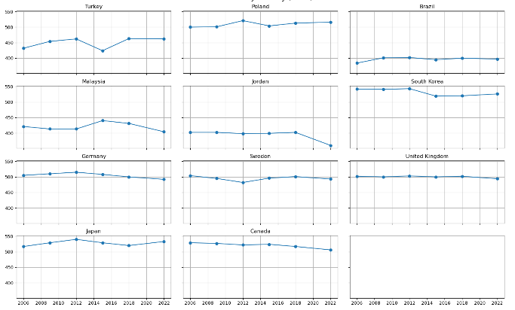
In the graph shown above, we see that the current years in the data set are visualised on a country basis by averaging the values taken from the PISA data set.
While PISA data is a data set with 3 different values as Math, Science, Reading, a general PISA score was created by taking the average of these three criteria. At the same time, as can be seen from the graph, PISA data has score data at 3-year intervals from 2006 to 2022.
Then, since it was not desired to lose the reliability of the data by making prediction from prediction, the scores of the years 2023 2024 were predicted with the linear regression model using only real data.
Thus, the loss of confidence in the data was minimised.

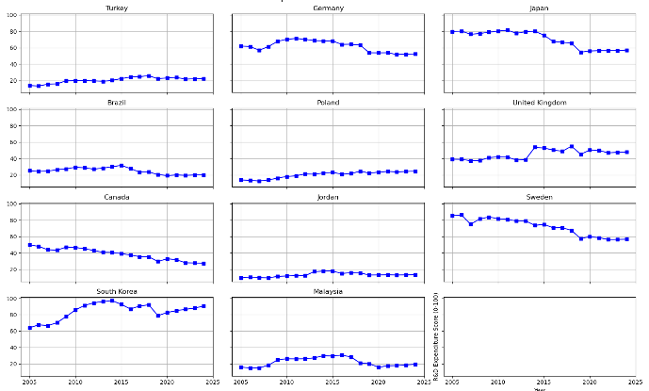
Likewise, linear interpolation and linear regression were used to create the data in the desired year range due to missing data in the WorldBank R&D Expenditure dataset.
In order to bring the R&D data to the desired range, linear interpolation was used for missing data in some countries and linear regression was used to complete the data of the selected countries for the last years.

Normalization
Since most of the data have specific score ranges, normalisation process is inevitable.

Since it is desired to evaluate the general scores over 100, the data were normalised to be evaluated over 100.

In general, Min Max Normalisation was used and Z Score Normalisation was also tried, but it was not considered appropriate and was not processed and used.

Since WorldBank R&D Expenditure data contains percentage values, Max Min Normalisation was needed to be used.
Thus, new scores that can evaluate the percentage scores over 100 have been created.
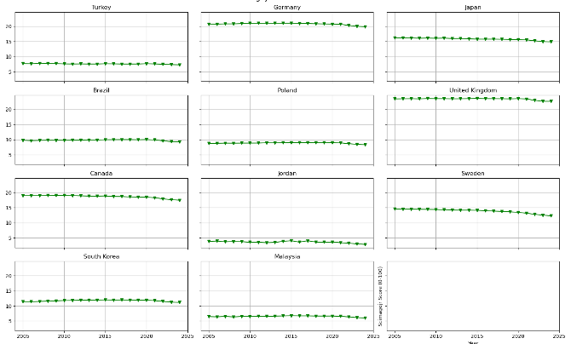

After the scientific_score Min Max Normalisation process produced from ScimagoJR data, it was noticed that although the countries had scores over 100, the maximum score was 22. It was understood that this was due to the fact that America made a big difference in the scientific world, and Z Score Normalisation was tried because the extreme values made such a difference.

Since there was no significant difference, Min Max Normalisation was used.

Weighting
The weighting, which is frequently used when generating the overall score, is scored according to the purpose of the data and whether it appeals to the general public. In order to maintain realism and consistency, the data set with general evaluations related to the criterion is weighted more.
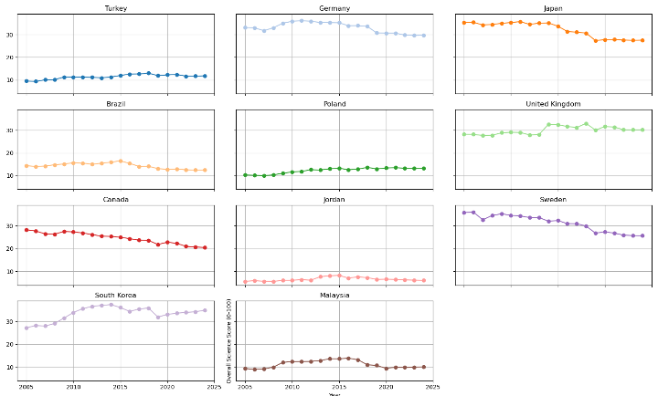

The weighting made while producing the Scientific Contribution overall score of the countries is as follows :
0.7 * ScimagoJR + 0.3 * R&D
This is because ScimagoJR data has a value that can directly measure scientific contribution and quality.
R&D Expenditure data is related to the budget allocated by countries for science. Although it measures how much importance countries attach to science, ScimagoJR data has a higher weighting because it measures scientific quality.
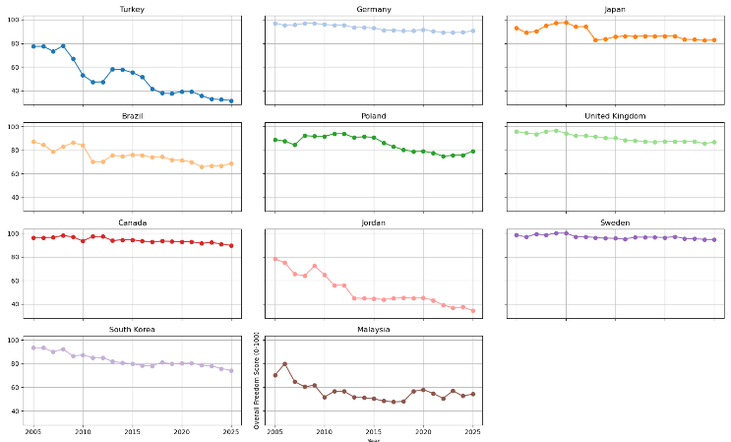
In the same way, the weighting was done as follows when producing the Freedom General Score of the countries:

0.6 * Freedom House + 0.4 * RSF

The reason for this is that RSF data only includes data on media freedom, while Freedom House data has a more general and inclusive data on personal rights and freedoms.
For this reason, Freedom House is weighted with 0.6 while RSF data is weighted with 0.4.

Conclusion and evaluation
In this project, Turkey is expected to show a decline since 20 years.
Developed countries (such as Germany, Japan) are expected to have an upward trend.
Countries such as Malaysia and Jordan are expected to have a slight decline or remain stable.

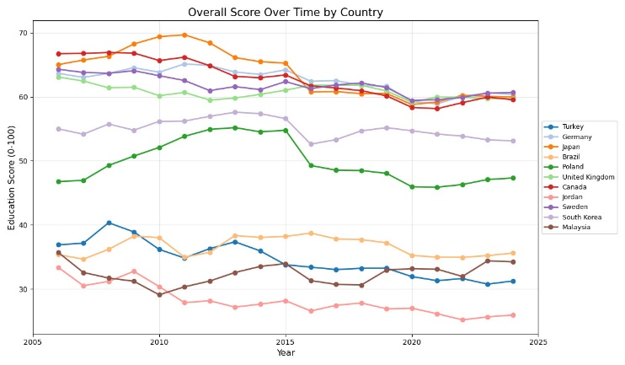
Despite all these expectations, it is evident that there is a decline in becoming an enlightened society throughout the world.

The reason for the lack of an expected result and the decline in developed countries may have many different reasons.
For example, even if countries such as Japan are really developed in many areas, it is a country where people die and commit suicide due to intense working conditions.
This is a situation that does not comply with the criteria of an enlightened society and therefore a decline can be considered.
Likewise, although Sweden is at an advanced level in terms of freedom and prosperity, the frequency of people committing suicide due to the Scandinavian depression is also high.

The decrease in the number of people who read in the digitalised world and the fact that events such as cinema and concerts can be held digitally may also be effective in the decrease in scores on a country basis.
In recent years, due to the popularisation of radical views in the world and the political right-wing movement gradually gathering people around it, it can be seen that freedoms have decreased worldwide, perhaps for this reason, a decrease may have been observed in countries around the world.

As mentioned at the beginning, since we cannot be completely sure of the accuracy of the results obtained, they are open to interpretation and many interpretations can be produced whether parallel to the results or not.

If we give an answer to the opinion mentioned at the beginning, we can conclude that Turkey can really go forward if it goes back 20 years.
2005 Overall Turkey Score = 36
2025 Overall Turkey Score = 31
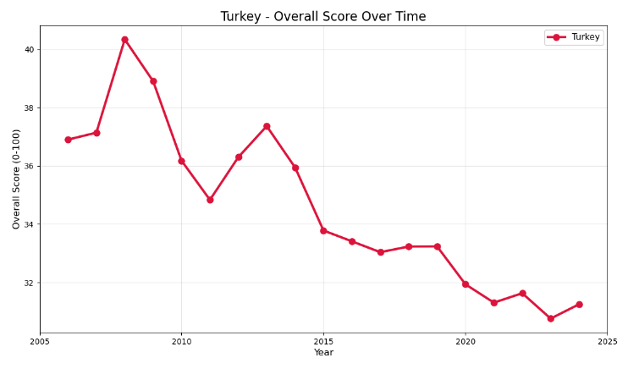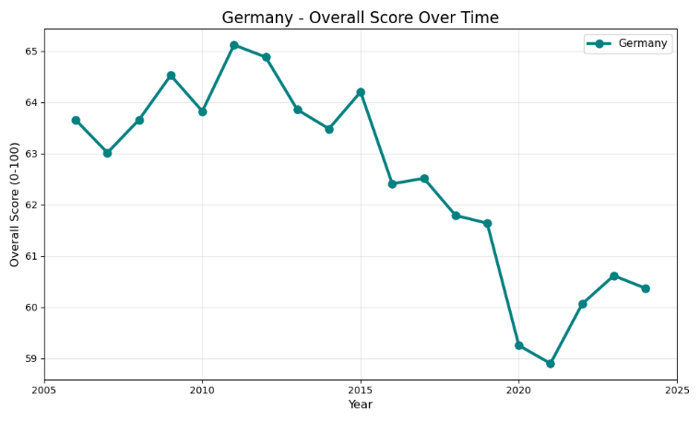
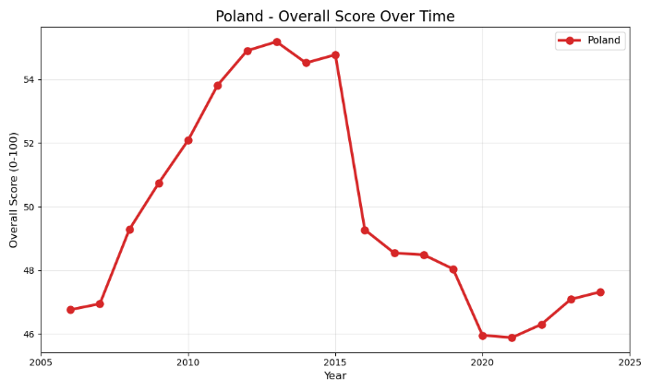
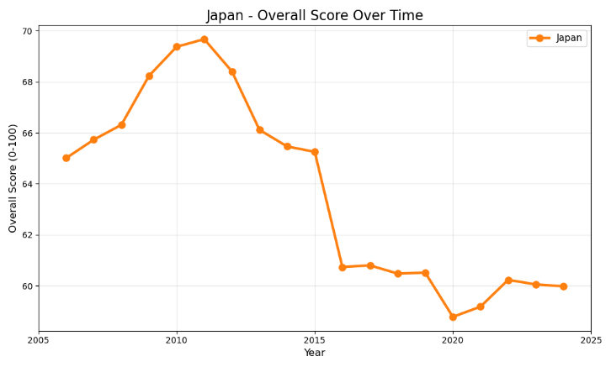
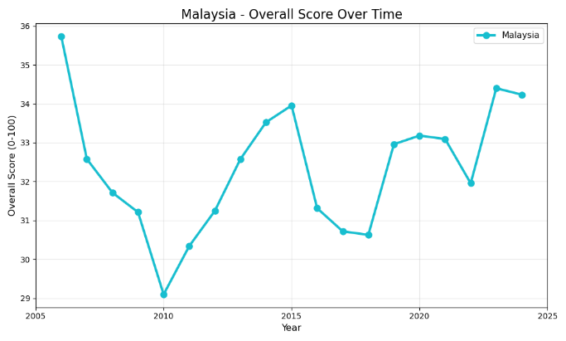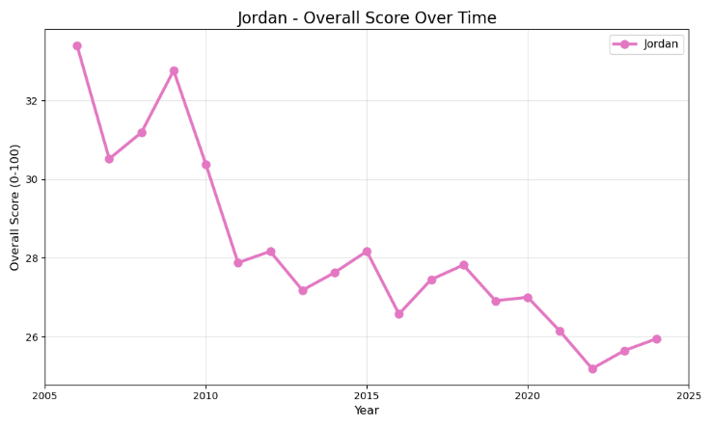
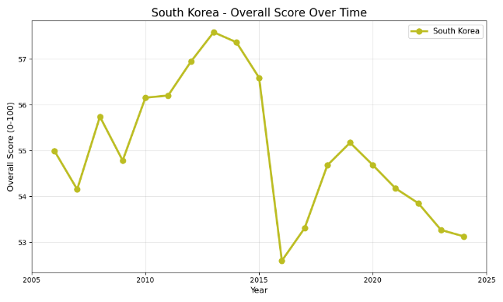
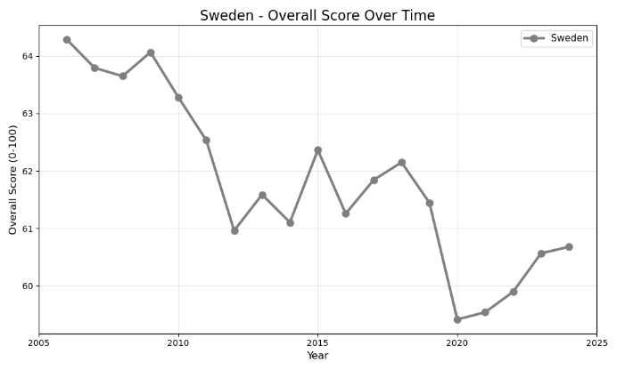
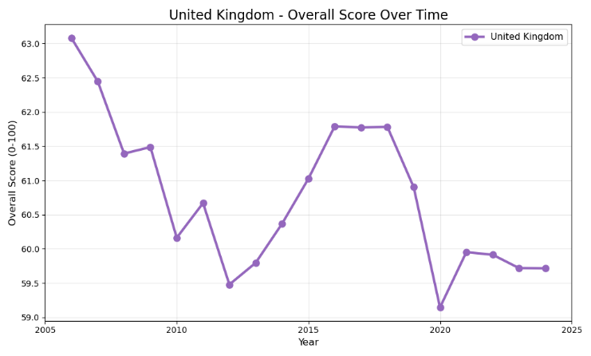

Note: The sudden drops seen in the given graphs should be carefully examined. Since the numerical score range of each graph is different, the graph may be misinterpreted.

The answer to another question we mentioned at the beginning was solved by making cholerisation between the criteria.
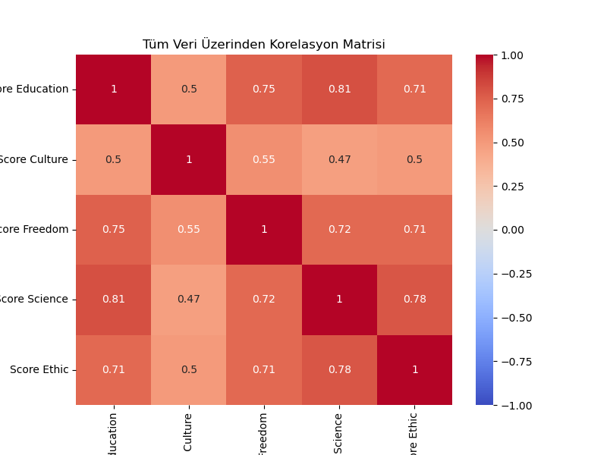

Based on the heat map, education and scientific contribution have the most positive relationship with each other.
The reason for this may be that we use University Ranking in the education score, but it is clearly consistent with reality.
Therefore, two of the criteria that have the most impact on countries are education and science.

SOURCES

https://www.kaggle.com/datasets/prasertk/pisa-scores-20062018?resource=download

https://www.kaggle.com/datasets/theworldbank/education-statistics

https://www.kaggle.com/datasets/raymondtoo/the-world-university-rankings-2016-2024

https://www.kaggle.com/datasets/justin2028/freedom-in-the-world-2013-2022
https://rsf.org/en

https://www.kaggle.com/datasets/justin2028/freedom-in-the-world-2013-2022

https://www.scimagojr.com/countryrank.php?order=it&ord=desc

https://data.worldbank.org/indicator/GB.XPD.RSDV.GD.ZS

https://uis.unesco.org/

https://www.transparency.org/en/cpi/2024

https://trends.google.com/trends

